Chapter 3 Battle Programming Project

Complete this programming project using your notes, the text book, and any online or in-class sources you like. Your work must be your own; you may ask a friend to look over your work, or discuss procedural decomposition with you, but you must write all code on your own. Don’t forget to use your 4 commandments of scope and error-checking algorithm.

**To receive full credit on this lab, you MUST submit a structure diagram or pseudocode-plan for each question.**

Exercise 1

*Write a method called battleStart that introduces the battle, prompts the user to choose their first Pokemon to battle, and outputs the pairing. Your output should look something like this:*

Another trainer is issuing a challenge!

Zebstrika appeared.

Which Pokemon do you choose?

You chose Arcanine!

It’s a Pokemon battle between Arcanine and Zebstrika! Go!

Exercise 2

*Write a method called damage that prompts the user for their base stats and reports damage done to their Pokémon in a battle. The formula used to calculate damage is:*

*Damage = $\left(\frac{2*Level*10}{250} * \frac{Attack}{Defense }*Base+2\right)*Modifier$*

*Modifier = Same Type Attack Bonus (STAB) * Random*

*Hint: The Pokemon game always selects a random number between 0.85 and 1.0.*

*Your output should look like this:*

Zebstrika used Thunderbolt!

Trainer, what are your Arcanine’s stats?

Level:

Attack:

Defense:

Base:

STAB:

HP:

Arcanine sustained 10 points damage. HP are now 70. *(Damage method returns value.)*

Exercise 3

*Write a method called statsTable that accepts the user’s pokemon stats and learned moves as parameters, and outputs something similar to this image:*

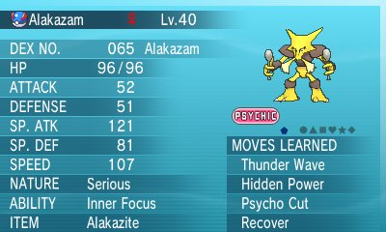

You are not required to align the columns of the tables in any fancy way, but if you may want to use escape sequences to align data. For your drawing, you may use code you’ve grabbed from the internet, or recycle an image you created earlier in the year.